Moffat Bay Marina
Week 6 — Marina Slip Reservation
Functional Test Results

Project: Moffat Bay Marina
Course: CSD 460
Description: Functional test results for the Marina Slip Reservation page and backend flow.
Developer: Aftabur Rahman / Green Team
Peer Tester: Alexander Baldree
Date: 2026/09/07

This document records four functional tests for the Moffat Bay Marina slip reservation feature. The tests cover slip selection, required-field validation, reservation rejection handling, and successful reservation submission/database persistence.

Test 1 — Slip Selection and Reservation Page Load
Test Objective: Verify that selecting a marina slip from the reservation flow opens the reservation page and displays the selected slip.
Developer: Aftabur Rahman / Green Team
Date tested: 2026/09/07
Peer Tester: Alexander Baldree
Peer Test Date: 2026/09/07
Step | Action | Expected Result | Developer | Peer Tester
1 | Open the marina slip reservation page with a selected slip. | The reservation page loads successfully without a server error. | YES | YES
2 | Verify that the selected slip number is displayed. | The selected slip number is displayed on the page. | YES | YES
3 | Verify that the arrival and departure date fields are available. | Both date fields and the Continue Reservation button are visible. | YES | YES
4 | Confirm the user can remain on the reservation page while reviewing the selected slip. | The reservation page remains available for the next step of the reservation process. | YES | YES

Comments: The reservation page loaded correctly and preserved the selected slip value. The page provides the expected arrival and departure date fields and a clear continuation control, allowing the user to proceed with the reservation.
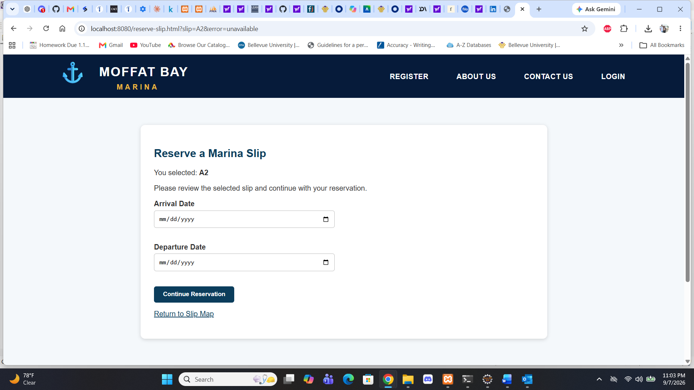
Screenshot 1: Reservation page showing selected Slip A2 and the reservation controls.

Test 2 — Required-Field Validation
Test Objective: Verify that the reservation form prevents submission when required arrival or departure information is missing.
Developer: Aftabur Rahman / Green Team
Date tested: 2026/09/07
Peer Tester: Alexander Baldree
Peer Test Date: 2026/09/07
Step | Action | Expected Result | Developer | Peer Tester
1 | Open the reservation page for a selected slip. | The selected slip and reservation form are displayed. | YES | YES
2 | Leave the required date fields blank and select Continue Reservation. | The browser prevents submission because required information is missing. | YES | YES
3 | Verify the validation message. | A visible browser validation message states that the required field must be completed. | YES | YES
4 | Enter an arrival date while leaving the departure date blank and submit again. | The form continues to prevent submission until the required departure date is supplied. | YES | YES

Comments: The form correctly prevented an incomplete reservation from continuing. The browser displayed a required-field message, providing immediate feedback and ensuring that the user supplies the required reservation dates.
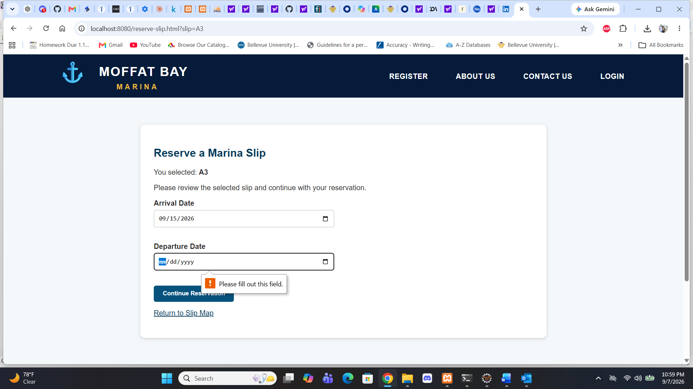
Screenshot 1: Browser required-field validation displayed when the departure date is missing.

Test 3 — Unavailable Reservation Rejection
Test Objective: Verify that the backend rejects a reservation request when the selected slip is unavailable for the requested reservation.
Developer: Aftabur Rahman / Green Team
Date tested: 2026/09/07
Peer Tester: Alexander Baldree
Peer Test Date: 2026/09/07
Step | Action | Expected Result | Developer | Peer Tester
1 | Submit a reservation request for a slip that is unavailable for the requested dates. | The reservation request is not completed as an active reservation. | YES | YES
2 | Observe the returned reservation page/error state. | The application returns to the reservation page with an unavailable error state. | YES | YES
3 | Verify that the selected slip remains identified in the reservation flow. | The selected slip remains visible so the user can choose another option or revise the request. | YES | YES
4 | Confirm that the unavailable request does not produce a successful confirmation page. | The request does not proceed to the successful reservation confirmation state. | YES | YES

Comments: The unavailable-reservation path correctly prevented the request from reaching the successful confirmation state. The application retained the reservation page and error state, which provides a safe failure path instead of creating an invalid active reservation.

Screenshot 1: Reservation page showing the unavailable error state in the URL for Slip A2.

Test 4 — Successful Reservation Submission and Database Persistence
Test Objective: Verify that a valid reservation is submitted successfully and that the reservation record is stored in the Moffat Bay database.
Developer: Aftabur Rahman / Green Team
Date tested: 2026/09/07
Peer Tester: Alexander Baldree
Peer Test Date: 2026/09/07
Step | Action | Expected Result | Developer | Peer Tester
1 | Select an available slip and enter valid reservation dates. | The reservation form accepts the valid reservation information. | YES | YES
2 | Select Continue Reservation. | The application processes the request and reaches the reservation confirmation page. | YES | YES
3 | Verify the confirmation message and selected slip. | The confirmation page states that the marina slip reservation was successfully submitted and identifies the selected slip. | YES | YES
4 | Query the reservations table for the selected slip. | A matching reservation record is present in the database with the expected slip, check-in date, and active status. | YES | YES

Comments: The valid reservation completed successfully and displayed a confirmation message to the user. The database verification also showed the reservation record with the expected slip, check-in date, monthly cost, and ACTIVE status, demonstrating that the backend persisted the reservation.
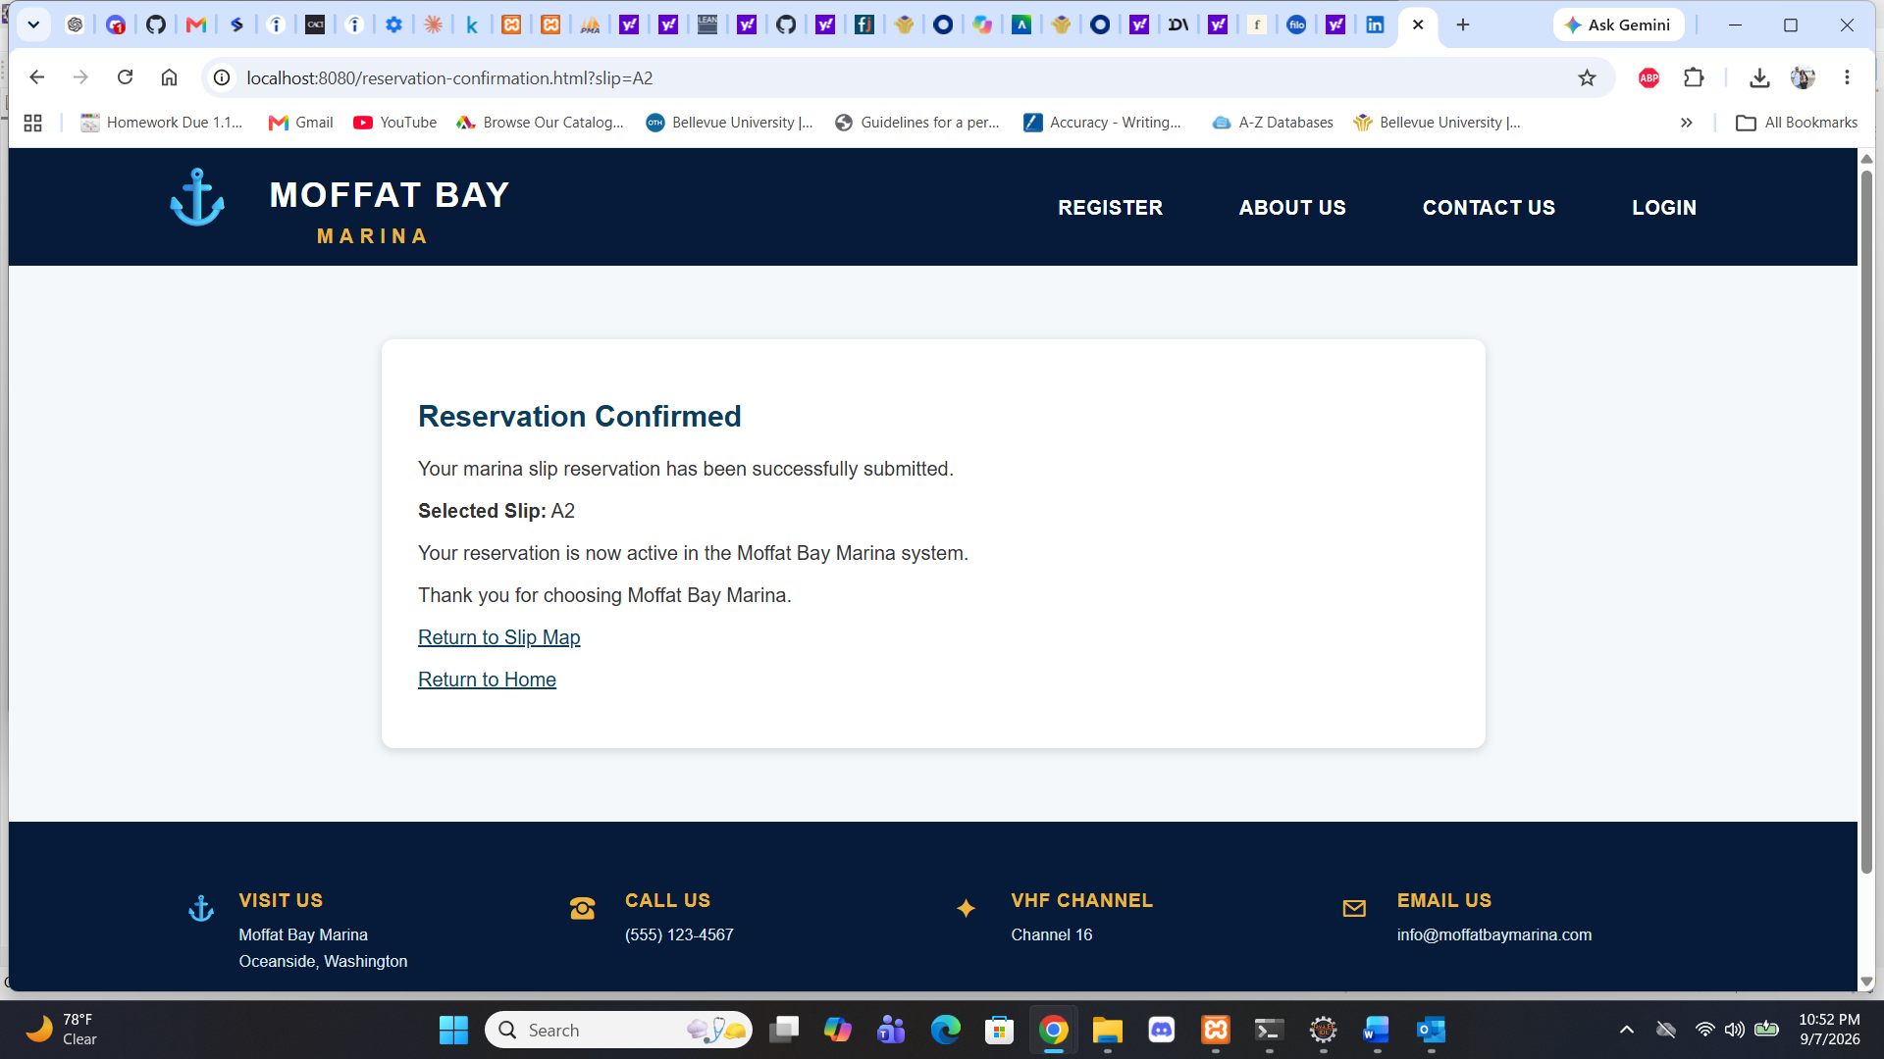
Screenshot 1: Reservation confirmation page showing successful submission for Slip A2.
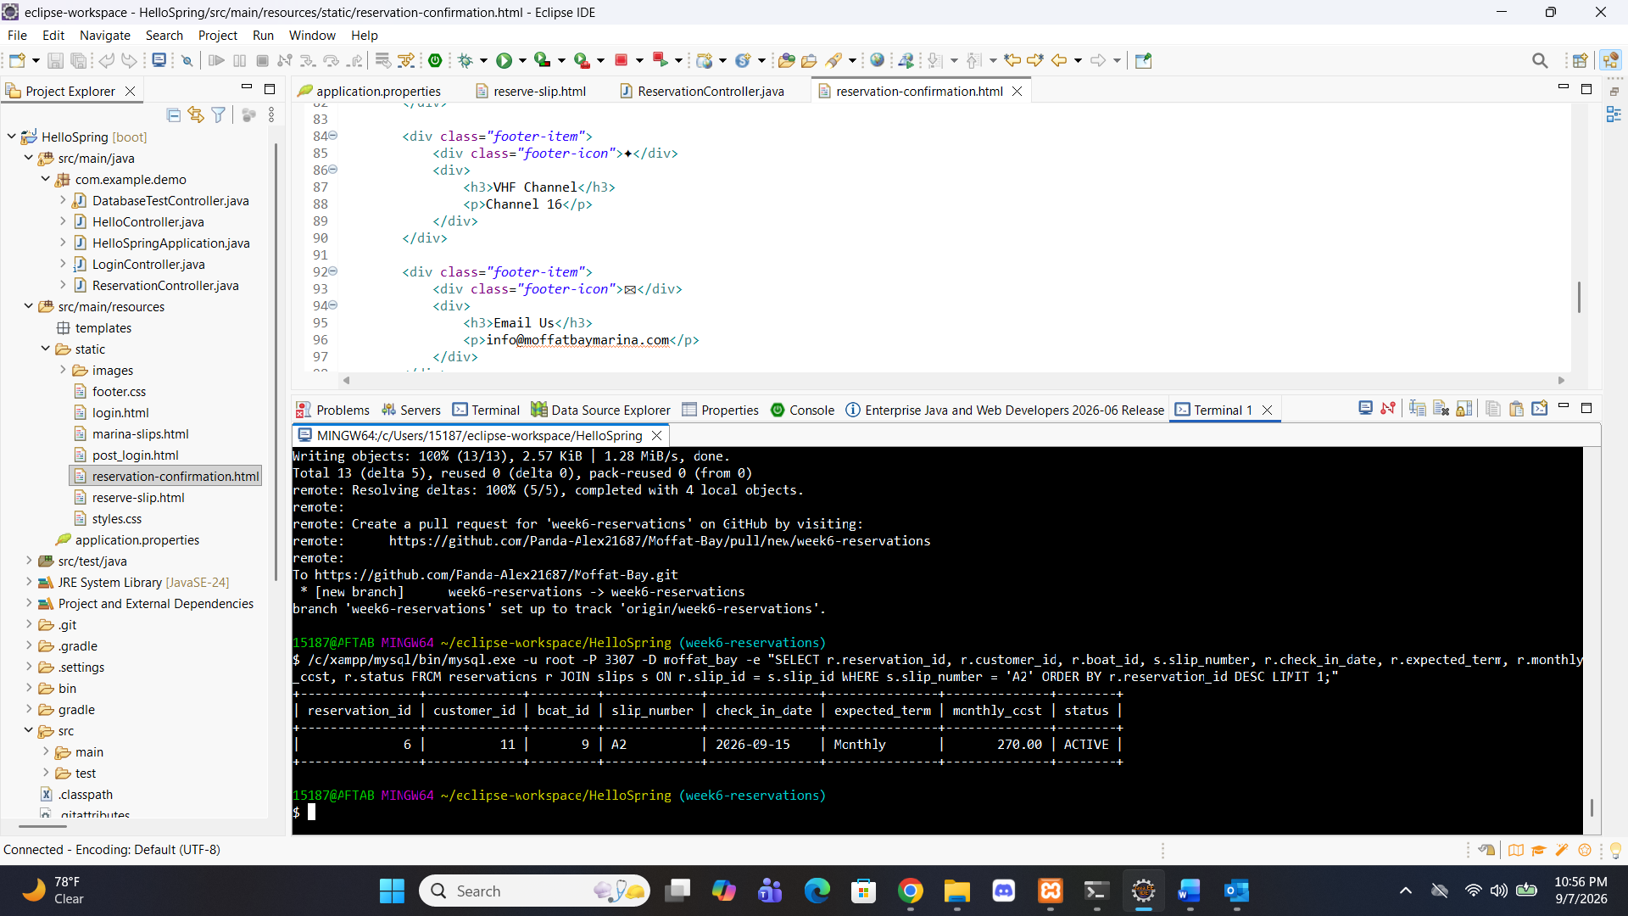
Screenshot 2: MySQL query showing the reservation record for Slip A2 with an ACTIVE status.

Overall Test Summary
All four functional tests were completed successfully by the developer and peer tester. The test results demonstrate that the Marina Slip Reservation feature supports the expected reservation workflow, prevents incomplete submissions, rejects unavailable reservations, and persists successful reservations in the Moffat Bay database.
Test | Result | Peer Tester
Test 1 — Slip Selection and Page Load | PASS | Alexander Baldree
Test 2 — Required-Field Validation | PASS | Alexander Baldree
Test 3 — Unavailable Reservation Rejection | PASS | Alexander Baldree
Test 4 — Successful Submission and Database Persistence | PASS | Alexander Baldree

Note: The test-plan template supplied for the project contains three test sections, while the Week 6 assignment requires four functional tests. This results document therefore includes a fourth test section so the Week 6 requirement is fully covered.

